***Report title: - Event Management And Ticket Booking***

**Name: Muhammad Aalim Baba**

**Registration Number:12321978**

**Name: Ansh Babel**

**Registration Number:12322150**

**Name: Ronak Sharma**

**Registration Number:12322267**

***Introduction: -* As per our project work we got an opportunity to develop a responsive website which is mainly based on Event Management And Ticket Booking .**

**So, we as a group of 3 members created a Event Management And Ticket Booking website which actually consists of 3 pages.**

1. **1st page represents the basic details and information regarding website and how this website is helpful for us.**
2. **2nd page is of login page and that appears when we click on login button (our event are restricted by a login page).**
3. **3rd is the final page which appears after login and that is to select the event and the we can book ticket on it for the respective event.**

**There are some more peripheral pages which consists of information about our site.**

***Technologies used: -***

**Our webpage is designed by the help of few technologies like**

* **HTML code**
* **CSS code**
* **JavaScript code**

**With the combination of these we have created a responsive website.**

**Module :-**

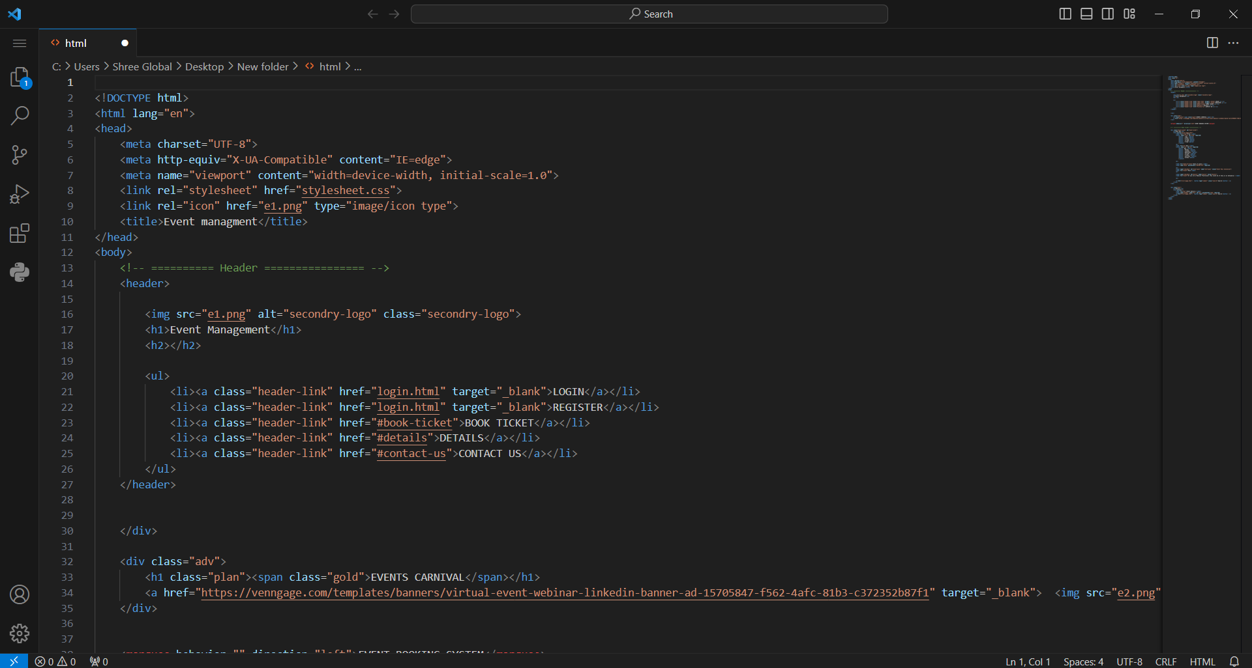

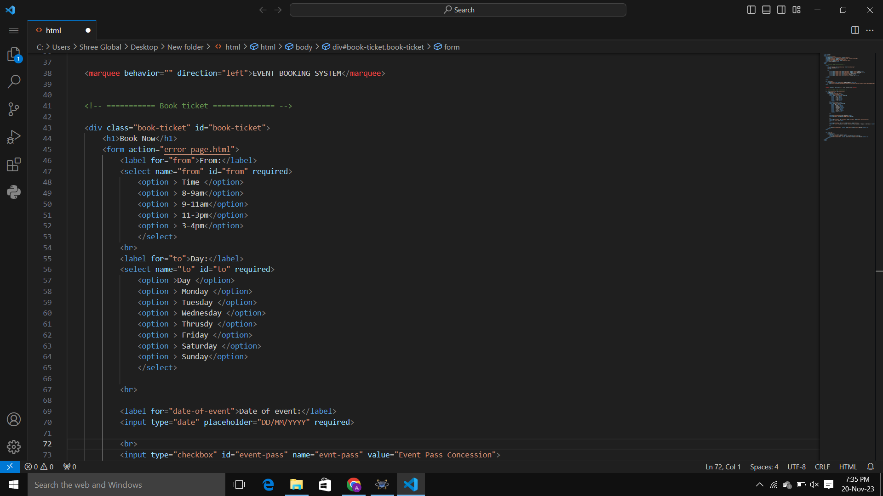

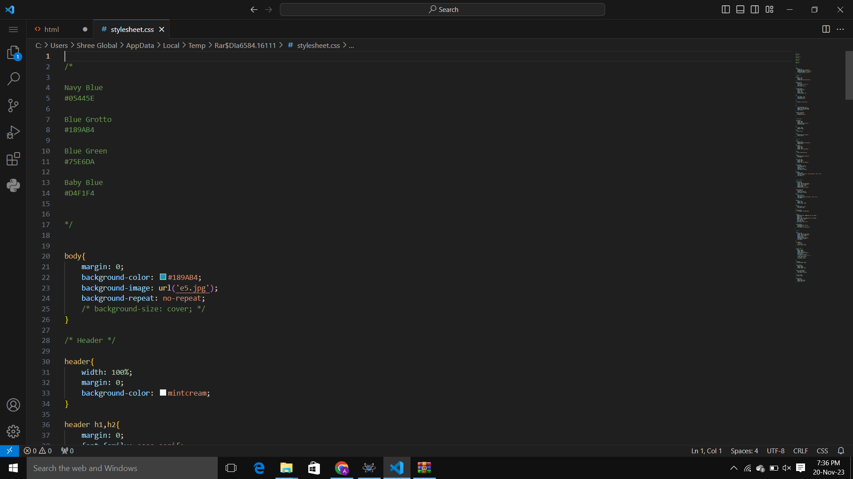



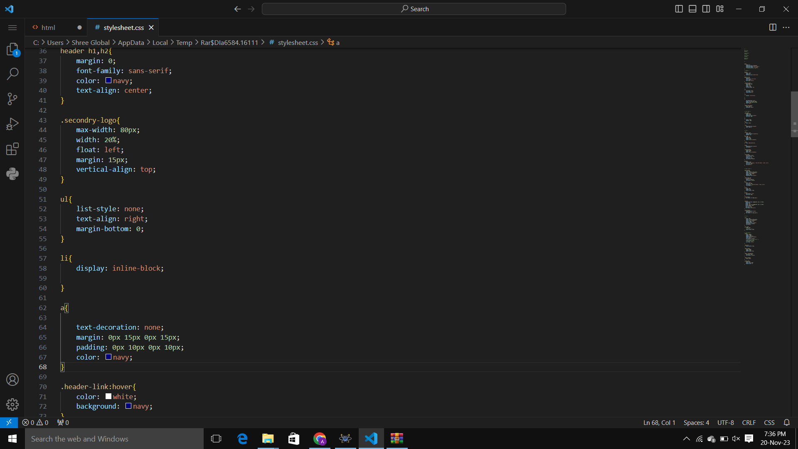

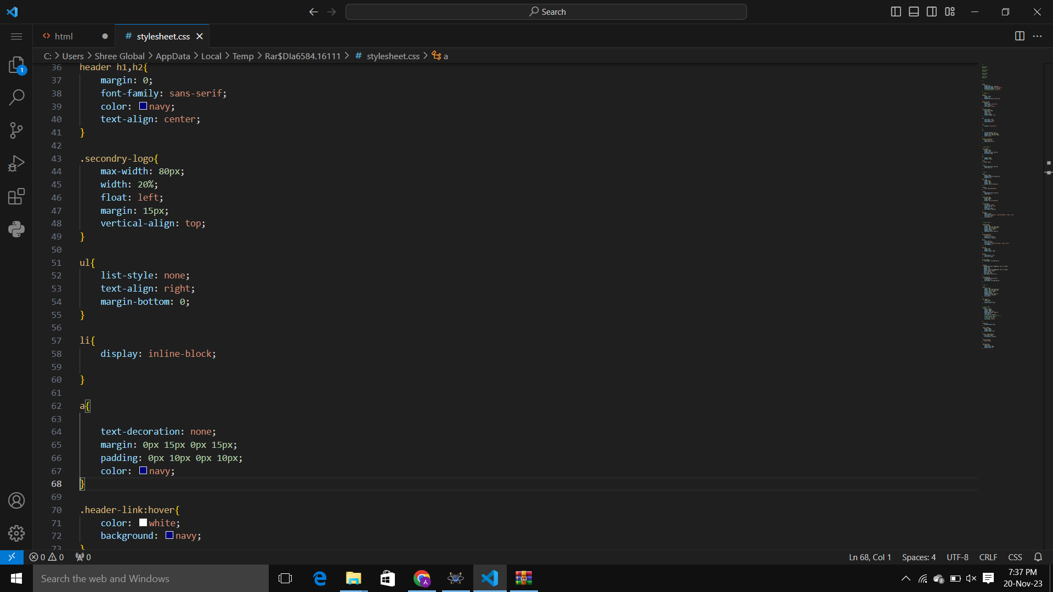

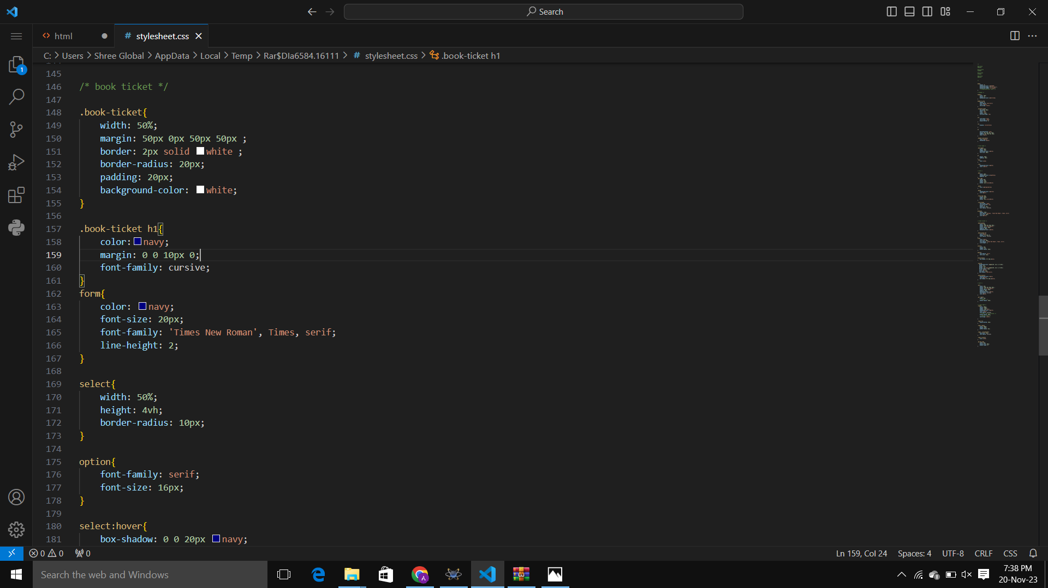

**Website snapshots: -**

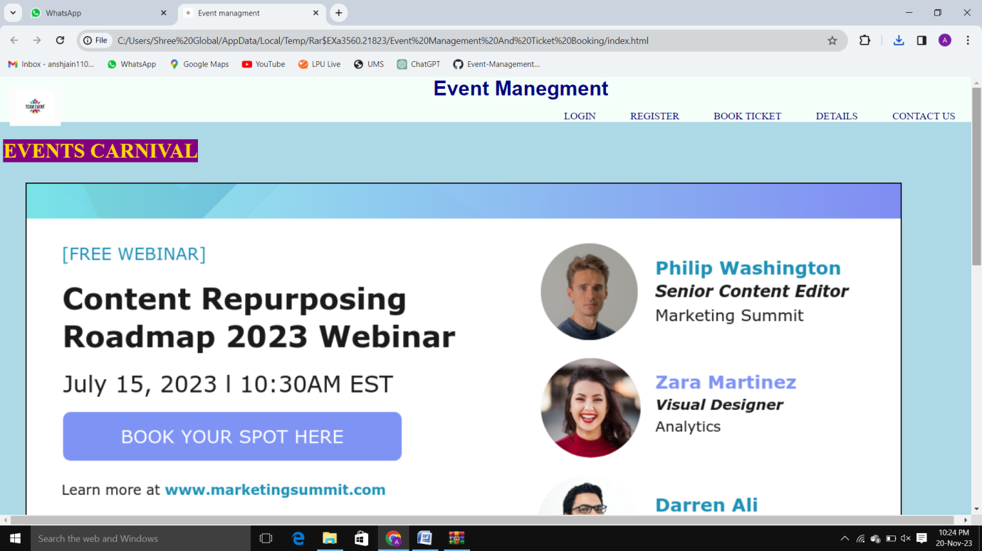

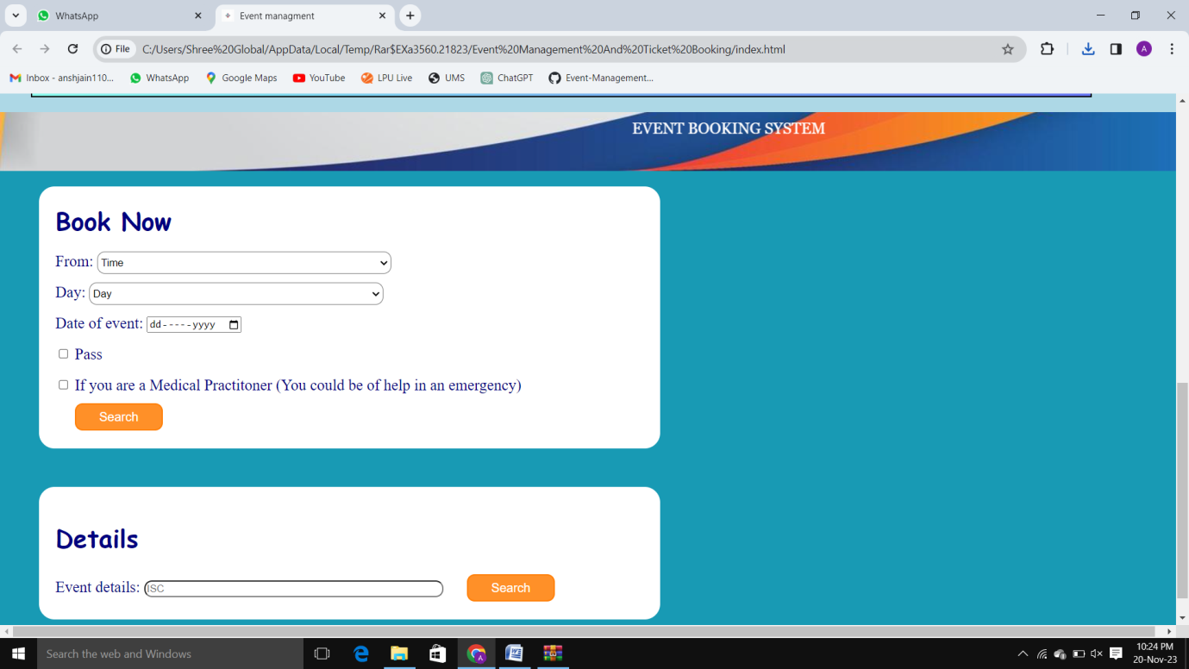

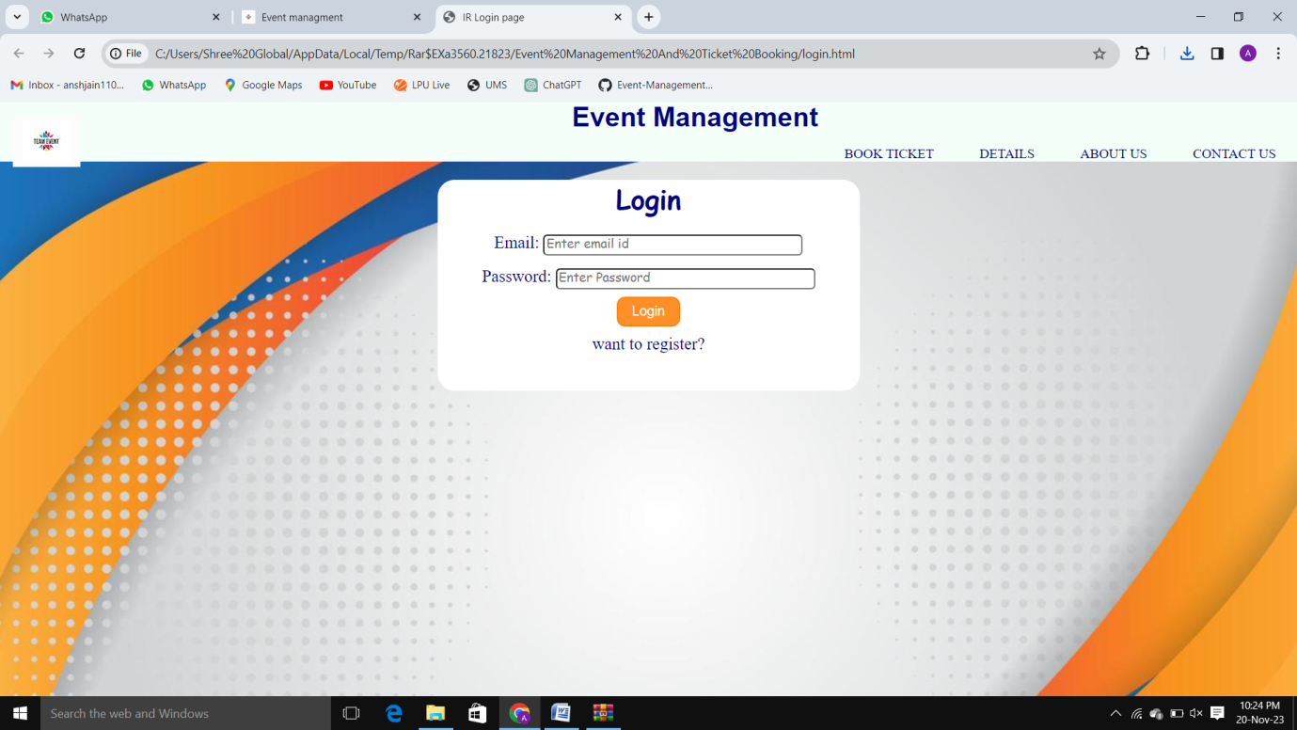

**References: -**

* **Class notes**
* **Lecture PPT**
* **Google (for images only)**